Step 1: Creating bucket S3

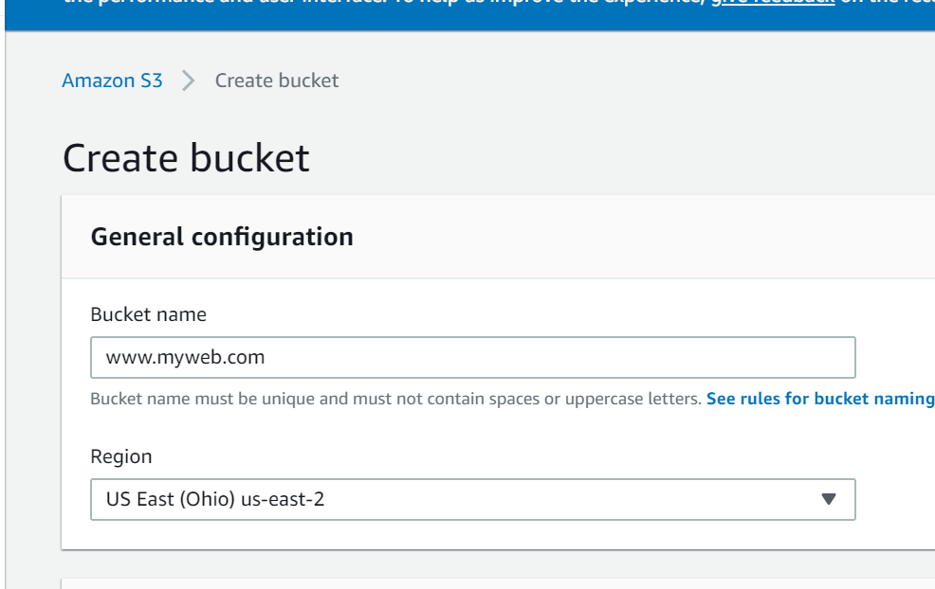

Step 2: Create name for file Index.html

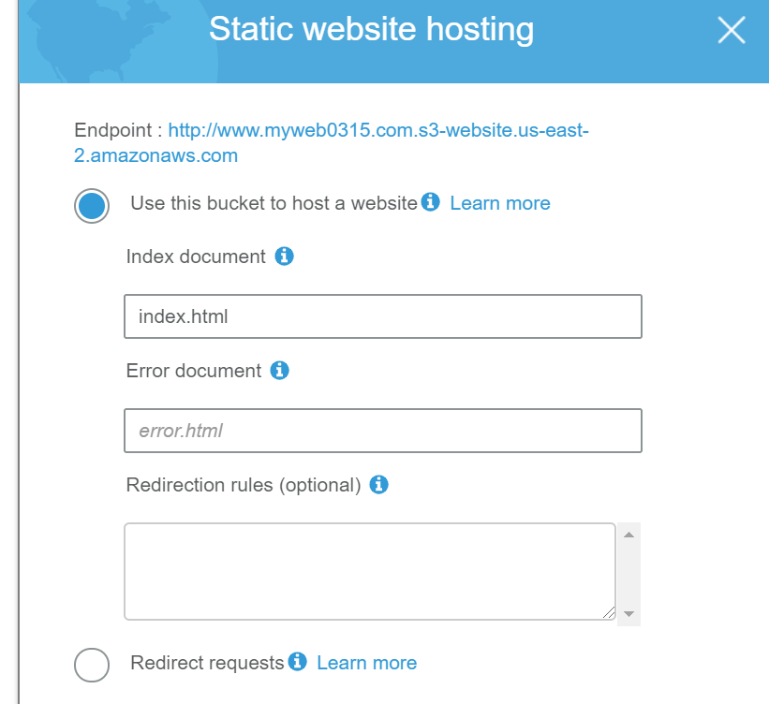

Step 3: Allow public access to website

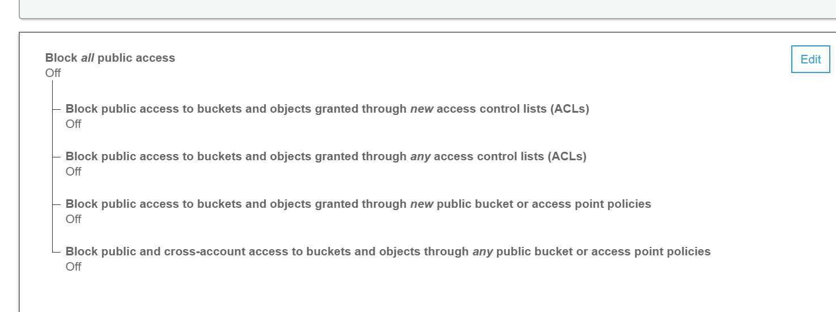

Step 4: Copy the link and run the website

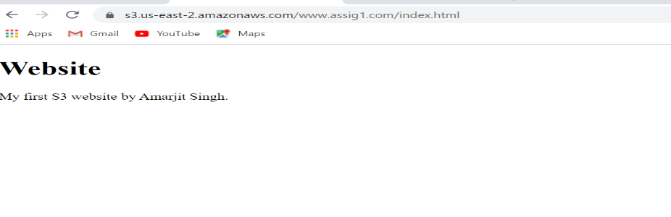

S2: Website

Step1 : Launch stance- Linux instance

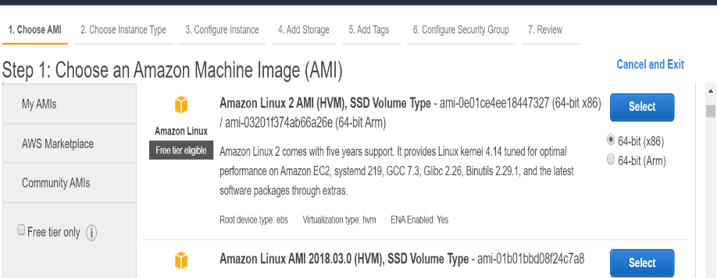

Step 2: Select http, https, ssh

SeSS

Sd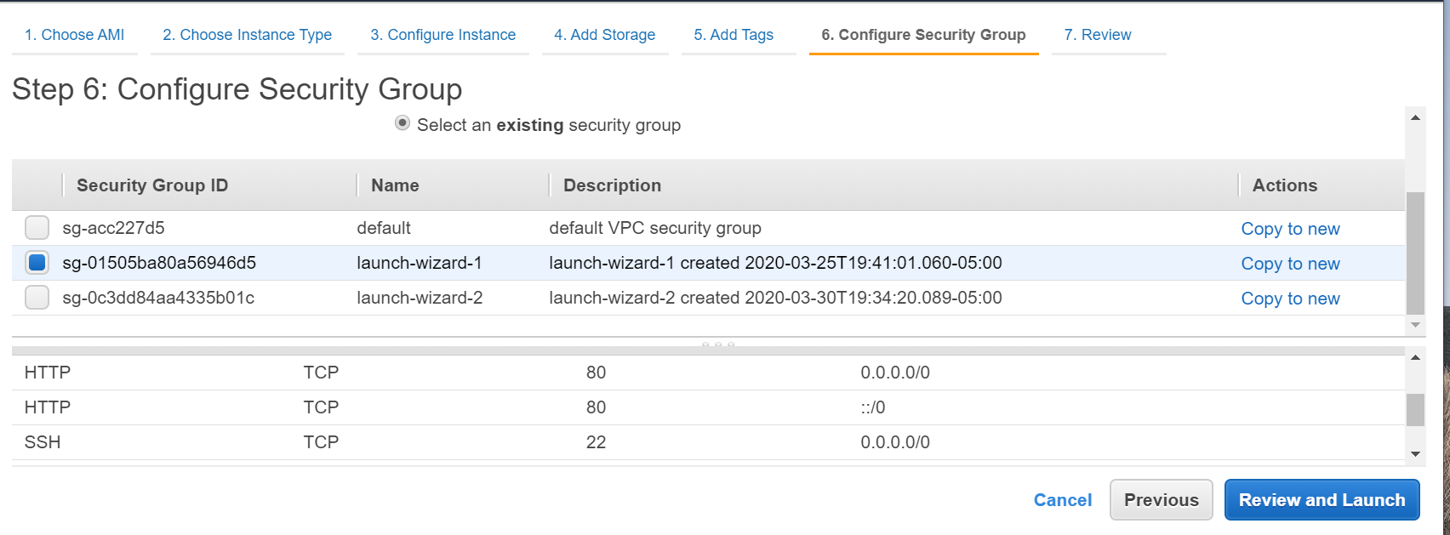

Step 3: Download key, launch command line, connect with ec2 user

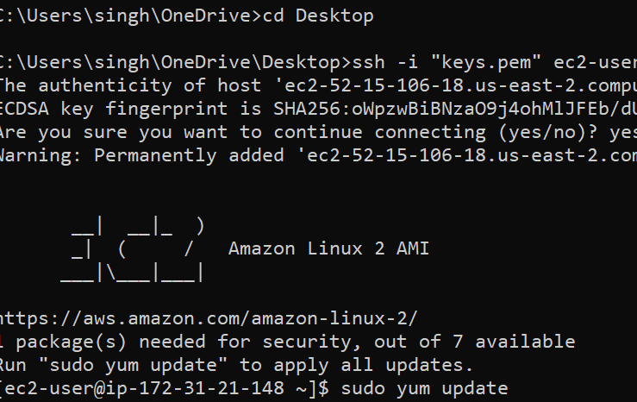

Step 4 install httpd

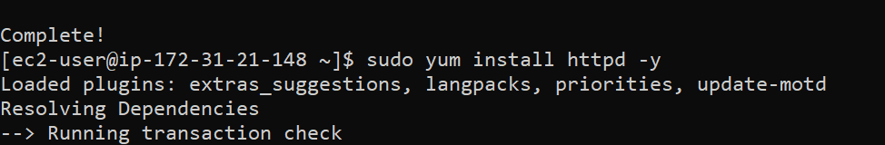

Step 5 start httpd – Sudo service httpd start and cd to /var/www/html

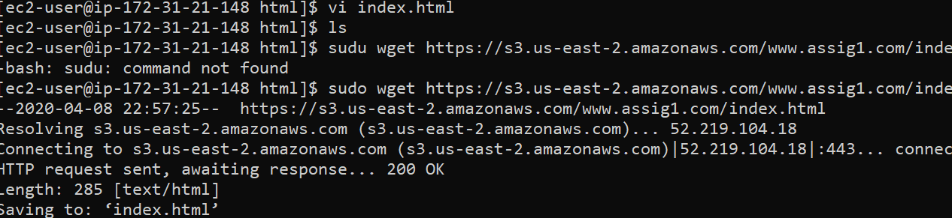

Step 6: get the file ; I download the file from s3 bucket using sudo wget link



Step 7: run the website with EC2

